Phone Cover with solar panel

By:

Date:

Abstract
The advancement in technology has led to a rise in the number of mobile phones. This paper aimed at finding ways through which the efficiency of phones would be expedited through the creation of a solar-powered case. Usually, the use of conventional electric methods has been viewed to be unreliable since one has to be confined in one place to ensure that the phone is fully charged. With a solar-powered case, this will be solved in the near future. In such a case, this research aimed at creating a phone, which will be charged independently using solar power without having to carry a charger at all. Thus, such a phone would be working for long hours without running out of power since one can access solar energy at any place, especially during the day. Another crucial way to meet the objective was to ensure that there is no extra load for the phone users in terms of the solar panels and cables to be connected to the phone to charge. Instead, the phone itself was poised to having an inbuilt solar charging system and will resemble the make of iPhone 7 to avoid inconveniences regarding load to the users. The paper also focused on various publications to add to the existing knowledge on how solar cases of the modernized phones would be fitted material that will optimize the solar energy trapped. With the knowledge of diminishing resources, the proposed product will be of great use to the conservation of energy since it will utilize green energy. It will thus meet the objectives of many countries across the world championing for conservation motives besides facilitating phones’ efficiency.
Introduction
Mobile phones have been an integral part of human lives. Individuals depend on phones for various uses like banking, communicating with family and friends, planning daily programs, managing their email accounts and social networking. Provided the vitality of mobile phones in the contemporary world, it is crucial that the phones work at top efficiency and ensures the battery has power at any time.
However, the batteries of cell phones always require charging every day depending on the usage frequency, and this means the battery may not withstand an entire day. The technology on mobile phone battery is limited, especially since the size and model moderation needed for contemporary mobile phones. Because of the limitations, a cellular phone battery, might not offer enough battery life for a phone. This project analyzes the usefulness of providing a solar panel powered cover that is portable enough to avoid carrying extra weight in the form of the charger or spare battery. Lastly, the device should be sustainable by embracing the green energy.
Literature review
Calabrese, Barton A, and Edna Tan. Stem-rich Maker Learning: Designing for Equity with Youth of Color. , 2018. Print.
This book discusses the procedures on modeling and making of phone cases with solar panels. The book offers a helpful guideline on improving the efficiency of existing phone cases with solar panels by analyzing the pros and cons of the designs with the aim of building better solar-powered phone covers. It also assists in modifying the precise angle for the solar cells to absorb more light from the sun.
Feinberg, Randall J. The Creative Adventures of Nelson Clarke. Cork: BookBaby, 2012. Print.
The book outlines a class conceptualization of using a solar panel in building phones while noting the importance of using solar energy. The students creatively sketch the designs on a blackboard to sell the idea to the rest of the class. It emphasizes the optimization of charging using solar panel built at the back of phone cases.
https://www.instructables.com/id/How-20-Make-a-Solar-Cell-Phone-Charger/
The link provides instructions on the procedures of building a solar powered phone case. It highlights the materials needed and the various cuttings for achieving a perfect solar powered phone case.
https://books.google.co.ke/books?id=L4z1DQAAQBAJ&pg=PT1&dq=iphone+7+features&hl=en&sa=X&ved=0ahUKEwizxtGAuLHeAhVCCuwKHQNlAGgQ6AEIKDAA#v=onepage&q=iphone%207%20features&f=false
The link describes the features of Iphone 7 model and its unique outlook. It also analyzes design changes on the phone.
Mohammad Asif, Shakir Baba & Sameer Ahmad Mir. (2018).”Wireless Solar Mobile Phone Charger. Volume 5, Special Issue 01, Jan.2018. Retrieved from http://www.ijaerd.com/papers/special_papers/ETIECE029.pdf
This journal highlights the importance of embracing phone cases using solar panels. It outlines the making process of solar cells, absorption of sunlight and the efficiency of the prototype model applied in this procedure. Lastly, it emphasizes on the usefulness of embracing solar energy over other sources that are hazardous to the environment.
Rauschenbach, Hans S. Solar Cell Array Design Handbook: The Principles and Technology of Photovoltaic Energy Conversion. Dordrecht: Springer Netherlands, 1980. Internet resource.
The book analyzes various designs of solar cell for phone covers using the photovoltaic principle of energy conservation. It explains the benefits of coatings towards the solar cells. The layers provide excellent transmissions features to the sheets as well as protective cover.

Engineering Standards
- An ultra-thin Solar cell with a cover glass, anti-reflection coating, electrical back contact and n and p-types of semiconductors (made from silicon).
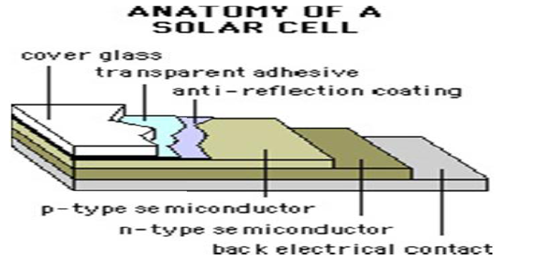
Source: https://globalwarmingisreal.com/2011/01/25/learn-how-to-build-your-own-solar-panel/
Figure 1: Solar cell anatomy

- iPhone 7 as the prototype model with measurements of 77.9 mm width by 158.2 mm height.
- solar panel measurements 67 mm wide and 110 mm high.
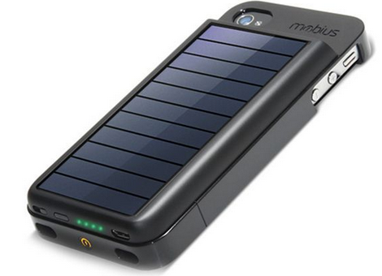
Source: phone.maykop.pro/mobius-solar-iphone7-charger
Figure 2; Solar panel covering backside of the cell phone
- Contain lithium-ion battery with 5.25 Wand 3.7v features.
- The semiconductor solar cell must be placed under a glass substrate on the front screen.
- Solar panel on the front has sensing lines, anti-reflective coating, a bonding layer, driving ranges and glass substrate.
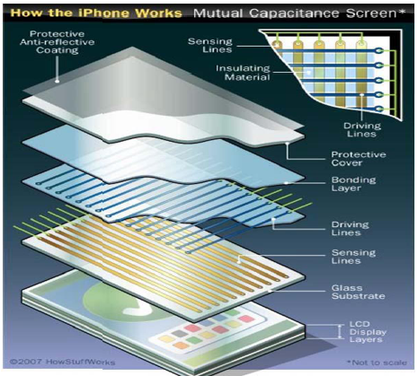
Source: https://electronics.howstuffworks.com/iphone2.htm
Figure 3: solar panel placed on the cell phone’s front-side
- The weight of the phone and solar panel must be must be under 150 grams
Methodology
Problem Statement
The objective of this research is to develop a phone case with a solar panel that can facilitate cell charging independently. There will be no need to carry extra power banks or spare batteries. The cell will be automatically loaded when exposed to radiant light. The cost of building the phone should be a relatively manageable figure of $120 or less.
Preliminary design and Research Ideas
The original research that was undertaken comprised phone with a similar concept, using solar panels and phones separately. The initiative produced few outcomes. Several ideas focused on solar panels chargers that are individually connected to the phone, meaning an extra load to carry just like a charger. This method did not meet the standards for this project.
Idea Refinement
The initial concept proposed the use of a separate solar panel that is connected to a phone using an electronic cable. However, several people did not embrace the idea since it meant an extra load. The project objective might have been achieved, but the model received some hesitation and incompatibility since it did not reflect what many people visualized. The iteration of the prototype only applied to few individuals who owned the device already.
Selected Design
IPhone 7 was chosen as the suitable model for the design. The phone has almost similar dimensions with the solar panels chosen (refer to engineering standards above). The case fits well at the back and front of the phone.
The cover was incorporated in a way that allows easy removal and fixing from the phone. The design could also allow an individual to connect the phone to a conventional charger while still attached to the phone cover.
Battery charging procedure
Apple iPhone 7 applies Lithium-ion battery. The battery is portable, light and can hold a charge for long periods. Solar cells are custom designed to charge satisfactorily from minimum percentage to the maximum (100%) at regular recharge time. During charging, electricity is relayed from the cell and causes the lithium ions migration from negative cathode to positive anode respectively. The battery will continuously charge. The process is endothermic meaning the battery absorbs heat during the recharging hence no heat is released in the procedure.
Discussion
Research
Product target
The research targets are charging a cell phone without the use of an electric plug. The solar panel will be infused on the phone cover. The solar cells will detect sun beans, absorb energy, and convert it to electricity hence charging the phone. The solar cells must be light and thin depending on the phone an individual uses since different phones in the market have varied back size. IPhones will be used as the phone model.
Solar cell
An analysis was undertaken within the community to examine solar panel development to tap into the solar power efficiently. With the diminishing effect on world resources, states encourage their people to embrace green energy initiatives to aid in the conservation of scarce supply. Research carried out revealed solar power has gained momentum since it is an abundant and free source of energy. Components of photovoltaic cells are put close to each other in frames, which facilitate energy absorption concentration. A coating is added to the panels to minimize energy losses and acquire maximum absorption capability. Also, on top of the layer, a glass plate is applied to provide safety and durability against any erosion (Figure 3).
Preliminary concept
The first procedure in this finding involved solar panel chargers, which were manufactured earlier. According to the research undertaken, nobody has shown the significant success of a solar-powered phone cover.
The initial iteration of the solar panel charger included a charger, which is separate from the phone. The solar panel would charge the phone using an electronic cable. This idea was modified to produce a wireless solar powered phone cover that attaches to the cell uniformly.
Design Refinement
The iteration of the prototype solar panel phone cover is widely distinct from the initial design because the preliminary idea was aborted. Pictures have been used to describe the procedures of making the solar panel.
Building procedure
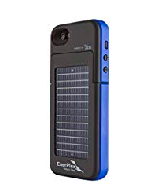

Figure 4: The EnerPlex Surfr for iPhone 5/5S item model number SFI-2000-BL
- It is the lightest in the market as it weighs only 89 grams or approximately 2.4 ounces.
- It is also the thinnest multi-functional battery case having dimensions of 16mm thickness.
- It measures 8*4.2*1 inches
- It uses 1 Lithium-ion battery, and the package comes with one included.
- It also has s 2000 mAh battery pack which is built into a convenient slim yet durable plan that is most likely to last double life your phone.
- It can be charged using a traditional wall charger but has an added advantage as it has a built-in solar panel at the back that can be used to recharge in case of emergencies and you will at no time have a dead phone.
- It is blue and provides a lasting solution for your iPhone 5/5S in all situations.

Building a solar phone cover:
- Connect the leads of the solar panel: Paint the leads flux on a back wire from one board to the red solar panel. Join the leads and connect using connecting iron.
- Perform heat-shrinking tubing: pass a slightly heated shrink tubing past the soldered leads. Heat until the tubing shrinks using a gun.
- Cut the wire from the Phone charger.
- Connect, heat-shrink, and flux the ends of the leads.
- Test the charging system by connecting to a radiant light.
- Again heat-shrink the leads of the solar panel.
- Tape the device and close: cover the rivets using tape.
Design Analysis
The most vital aspect of a solar panel is the extended lifespan they can go without faultiness. The solar panel can provide a lifetime of energy like the rods of nuclear fuels without polluting the environment. The solar-powered phone case operates without mobile parts hence no noise and reduced maintenance required. The cell can be charged anytime, anywhere just by positioning it upside down (Figure 2).
Costs
Task Name | Quantity | Part |  | Cost (per item)
Electrical items
 | 2 | Solar cells |  | $53 each
 | 1 | 22 Gauge Wire |  | 29cents
 | 5 | Resistors |  | 36cents
 | 1 | Circuit board |  | $6.34
Mechanical items
 | 1 | Glue |  | $1.98
Total Cost |  |  | $116.41

Timeline
Task | Duration | Beginning | End
Started looking for a topic (Phone Cover with Solar Panel) | 5 days | August 24, 2018 | August 29.2018
Gathering data | 4 days | August 31, 2018 | September 4,2018
Writing introduction | 6 days | September 6,2018 | September 12, 2018
Introduction submitted | 1 day | September 17,2018
Started writing proposal | 12 days | October 3,2018 | October 15, 2018
Submitted the proposal | 1 days | October 19,2018
Editing the proposal | 9 days | October 27,2018 | November 5, 2018
Final proposal submit | 1 day | November 12, 2018

Works cited
Calabrese, Barton A, and Edna Tan. Stem-rich Maker Learning: Designing for Equity with
Youth of Color. , 2018. Print.
Feinberg, Randall J. The Creative Adventures of Nelson Clarke. Cork: BookBaby, 2012. Print.
https://www.instructables.com/id/How-20-Make-a-Solar-Cell-Phone-Charger/
Mohammad Asif, Shakir Baba & Sameer Ahmad Mir. (2018).”Wireless Solar Mobile Phone
Charger. Volume 5, Special Issue 01, Jan.2018. Retrieved from http://www.ijaerd.com/papers/special_papers/ETIECE029.pdf
Rauschenbach, Hans S. Solar Cell Array Design Handbook: The Principles and Technology of Photovoltaic Energy Conversion. Dordrecht: Springer Netherlands, 1980. Internet resource.
Garden, Home. "How The Iphone Works." HowStuffWorks. N.p., 2018. Web. 11 Nov. 2018. Retrieved from https://electronics.howstuffworks.com/iphone2.htm
"Learn How To Build Your Own Solar Panel." Global Warming is Real. N.p., 2018. Web. 11 Nov. 2018. Retrieved from https://globalwarmingisreal.com/2011/01/25/learn-how-to-build-your-own-solar-panel/

